**FAQ’s**

**How do I book a court?**

All play must be pre-booked via our online booking system and all members added to a booking. Please follow this link:

<https://berkhamsted.aspsystems.co.uk/sdbookit/bookitasp.dll/new>

Or the link on the top right-hand side of the club website homepage.

If you do not have your court login details please contact the Club Manager at manager@bltsrc.co.uk.

**Main things to highlight with booking courts:**

* You need to add your opponent’s name to the booking. A list of members is available for you to select from. Start typing the surname in the box and the member will pop up.
* If you do not add another player/s to your booking it will automatically get cancelled the night before the booking and no refund will be given.
* Courts can be booked up to 2 weeks in advance on a daily rolling basis
* Members can have a max of 9 hours of bookings at any one time for tennis, no limit for squash.
* You cannot book more than one court at the same time
* You can add money to your account via the booking system for guest fees and floodlights. This can be done via Paypal or with a debit or credit card.
* **Please cancel courts if you no longer require them**

**Adding an opponent**

You need to add another member or guest to your booking to ensure that your court isn’t cancelled the night before the booking. To add another member - click on the ‘**add participants’** list on the booking you have made. Then type in the members surname in the box and select.

If you are bringing a **guest** – add ‘Senior Guest – tennis’ or squash etc. to your booking and pay the guest fee. You can bring as many different guests as you like but the same guest can only come a max of 6 times in a season before we would ask them to be fair to other members and join.

**Adding a guest**

Guests can be brought to the club by senior members but need to be added as a ‘Guest’ to the booking and payment is made at that point so you need money on your account – see above.

**Tennis floodlights**

Floodlights can now be activated online from your PC, laptop, tablet, mobile phone.

**NB: Lights can only be added and paid for on the day of the booking in question.**

**How to activate the lights:**

* Login to the online court booking system
* Once logged in, go to MAIN MENU and then select MY BOOKINGS.
* Find the booking in question and on the day of your booking, the booking will have an option to MANAGE LIGHTS.

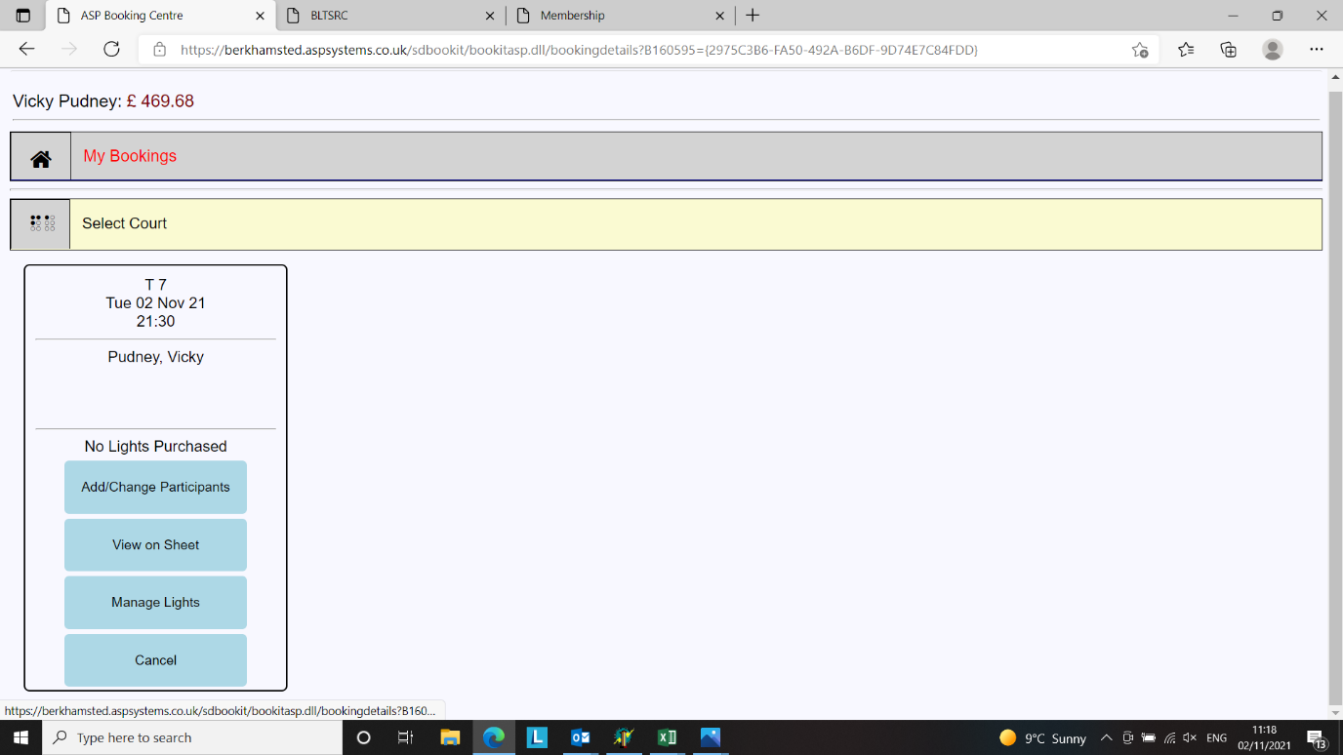

* First select the START time for the lights to come on. **NB:** If you are pre-booking earlier in the day as opposed to putting them on as and when you need them whilst playing, **please err on the side of earlier rather than later**. The system currently has a glitch that will not allow you to go back in and select an earlier start time once the original start time has been set.

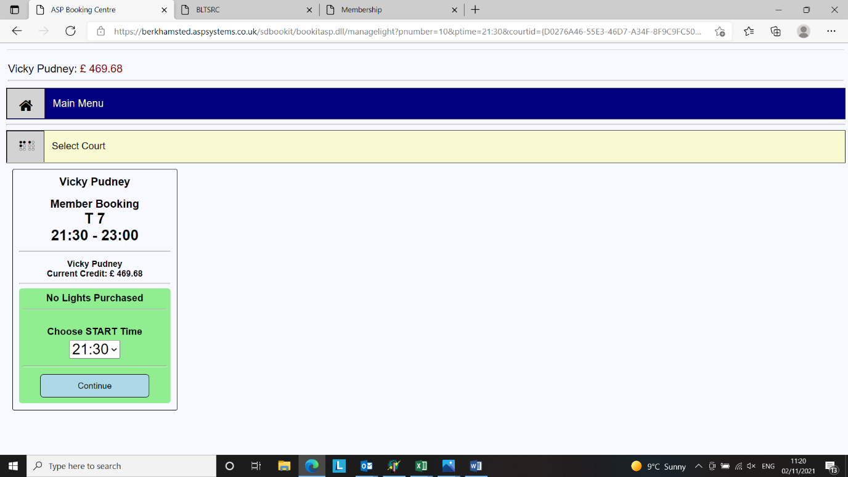

* Next, select the OFF time for the lights. **NB:** Please ensure that you allocate enough time for your game to avoid the lights going off and you still needing more time. **If you want to put them back on again once they have gone off** then there is a 15-minute cooling down period before they can be re-activated!
* Lights can be booked for 5-minute increments.
* Select the length of time you wish to have the lights on for.
* Then click BUY LIGHTS.
* The lights will then come on at your scheduled time.
* If you find you finish your game before the lights are due to go out you can select PAUSE LIGHTS on the online booking and they will switch off. At the moment there is no auto-refund to member accounts for this but something we would like to add in the future but it will save energy!

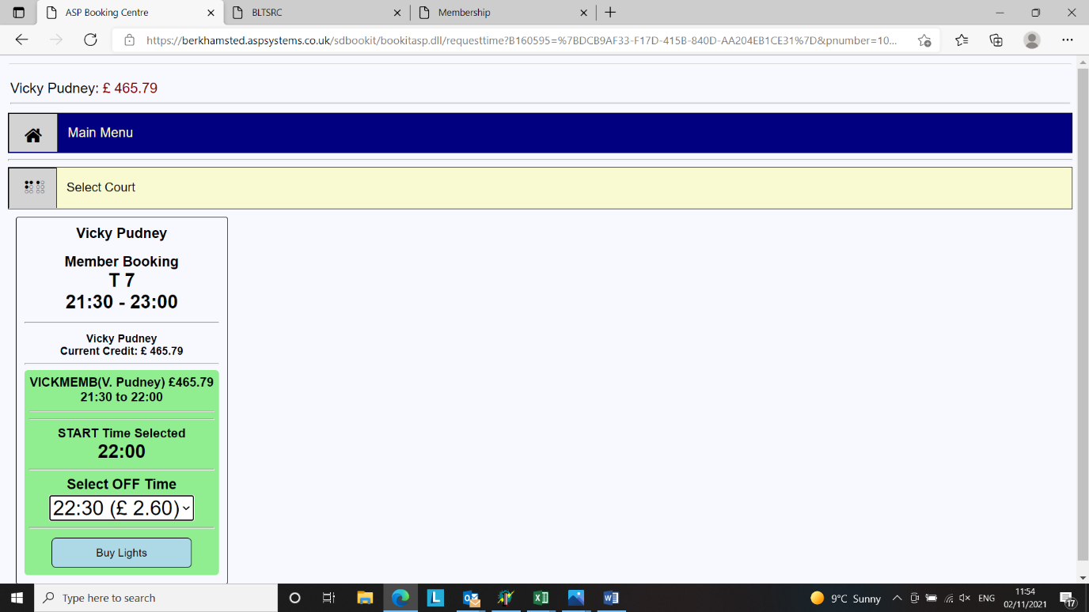

**Points to note:**

* Floodlights cost £5.20 per hour.
* Lights are not available on court 6b. Or courts 7-9 until the new lights have been installed (ETA end of October 2022)
* You will need to have credit on your account in order to be able to activate the lights. This can be done via the TOP UP CREDIT option which is found on the MY BOOKINGS dropdown once you have logged in to your account.
* Floodlights can be activated and paid for online by any member listed on the court booking in question. It is not possible to manage the lights online on a booking which does not include your name. However, anyone can add lights to any court via the kiosk. Therefore, if you are doing this please ensure that you put your lights on the correct court!
* Lights can be booked for immediate use from a mobile phone at the club.
* Lights can be cancelled (online) to save them being wasted if you finish playing before the lights are due to go out. Select PAUSE LIGHTS on the booking in question to turn the lights off. There is also a RESUME button if you want to put the lights back on again eg – in the scenario where there is a rain shower. Note the 15-minute bulb cool down will still apply.
* Lights can also be pre-programmed to come on at a specific time e.g. if you have a 7pm-8pm booking, you can set the lights to come as needed before you leave home. It is also possible to set the lights to come on part way through your booking if you do not need the lights at the start of your booking e.g. you can pre-book them to come on 30 minutes into your booking.
* It is possible – should you wish to do so – for more than one member listed on the booking to activate, and pay for, part of the session. This would require each member to book their part of the session individually. **BUT PLEASE NOTE THAT the earliest start time still needs to be booked first as it isn’t possible to go back in and select an earlier start time later.**

Flood lights can only be booked and paid for on the actual day of the booking. Floodlights are an extra cost (£5.20 per hour).

**Who do I contact about coaching?**

**Tennis**: Tyrell Diaz Stevens on 07830448233 or email info@berkhamstedtennisfit.com.

**Squash:** Adam Fuller on 07751 239 472 or email [adam@best-academy.co.uk](mailto:adam@best-academy.co.uk).

**Resetting my password**

We have two login areas – one for court booking and another for member related information and the box leagues.

Link to court booking: <https://berkhamsted.aspsystems.co.uk/sdbookit/bookitasp.dll/new>. You can reset your password for this area by clicking on the [Forgotten/Reset Password](https://berkhamsted.aspsystems.co.uk/sdbookit/hapaasp.dll/emailrequest) link.

Link to members area: <https://www.bltsrc.co.uk/page/my_membership>. You can reset your password for this area by clicking on the [Forgotten Password](https://www.bltsrc.co.uk/admin/resetpassword) link.